Name : Vishal Jha

Batch : Data Engineering

Date : 25-01-2024

Topic : Python Assessment – 01

Today we started with Python introduction, Python is a high level, dynamic and interpreted language developed by Guido van Rossum.

It is very easy and understandable language to start with.

**Python Features:**

* Free and Open Source.
* Easy to code.
* Object-Oriented Language.
* High-Level Language.
* Python is an Interpreted language.

**Applications of python :**

* web development, uses django, flask.
* data science , Numpy, Pandas.
* automation and scripting.
* Desktop GUI applications.

**Python data types :**

Integer ex: a= 580

String ex: s = “abhi”

Float ex: a = 12.05

Complex ex: a = a+3j

List ex: a = []

Tuple ex: a = ()

Set ex: a = set()

Dictionary ex: a = {}

Python basically takes string data type as default. We need to convert it according to our choice.

**Type ()** :

In order to know the data type

a=5

print(type(a))

It will return integer

s="abhi"

print(type(s))

It will return string

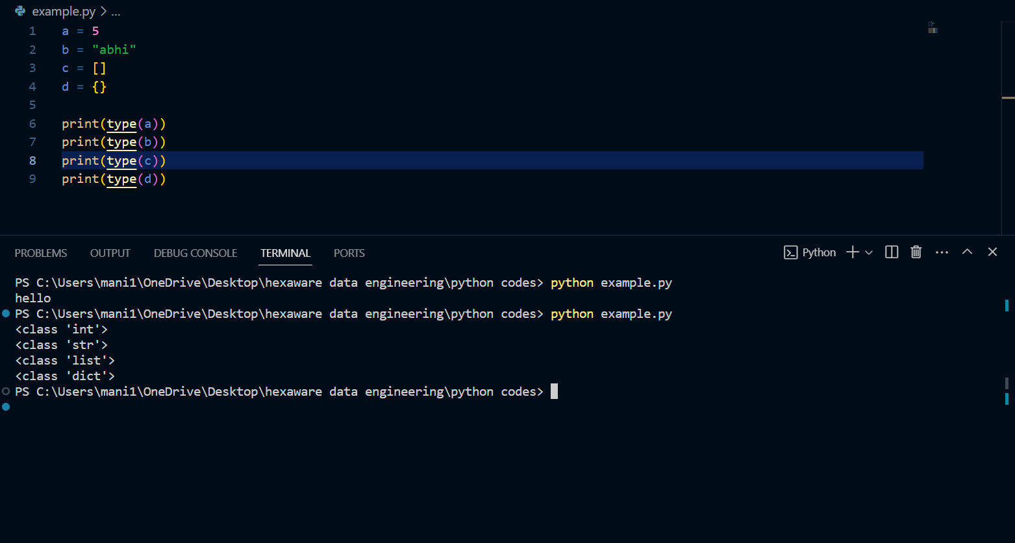

Indentation is very important in Python.

**Print ()**

Print function displays the output to the screen.

